# Core Global Issues and Solutions*

Helmut Burkhardt, Toronto, Ontario, Canada 15-05-08

Survival is the core global issue for humanity; it rests on two pillars.

* The first pillar of survival is peace.
* The second pillar of survival is a healthy environment.

When vital resources are insufficient for all, conflicts arise. This has been the prevailing condition of a growing human population in our finite world. Therefore, resource wars were natural and peace a time between wars. The winners had access to vital resources and the losers suffered or perished.

With nuclear weapons and the possibility of mutual assured destruction all has changed. There are no winners, all are losers and wars are no longer practical for gaining access to vital resources.

The realistic solution for survival is to adapt the ecological footprint of humankind to the ecological capacity of the Earth. For this three actions are necessary:

1. Changing to environmentally friendly technologies,
2. Regulating the average per capita resource consumption, and
3. Getting world population to a sustainable level.

All three necessary actions are a politically inconvenient truth, which challenges all individuals and institutions. This challenge can only be met in a just and civilized way by a united world with good global governance. (See **Fig 1** below for the trade-offs between the three steps).

Voluntary measures and multilateral International agreements are not effective. A good global government is required to legislate and enforce the necessary steps for a just and sustainable world. Good global governance with executive power replaces the military law of force with the peaceful force of law. In an age of reason this makes good sense, economically, socially and ecologically.

The mandate of the Science for Peace Working Group on Good Global Governance is to raise the public awareness of global governance issues. Please endorse our call and see other posts on our website [www.goodglobalgovernance.org](http://www.goodglobalgovernance.org/)

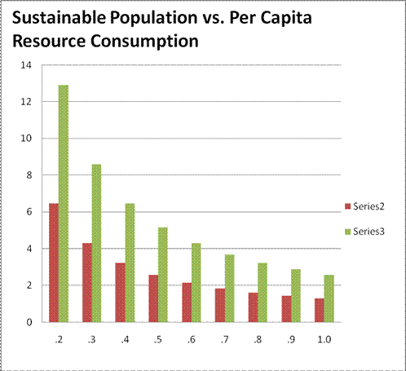

**Fig. 1**

*The vertical axis gives the sustainable world population in billions as a function of the ratio of per capita consumption of resources to the per capita consumption of today’s rich (A/*Ar*). The red series assumes present day carbon based technology, the green series assumes zero carbon, total renewable resource based energy technology. (*The author presented this figure to the Roundtable on Food and Population of the Science for Peace and Canadian Pugwash Group Global Issues Project on November 21, 2011, Ryerson University, Toronto ON Canada).

*This note summarizes a PowerPoint Presentation scheduled for the World Federation of Scientific Workers Meeting in Barcelona, Spain, May 12-16, 2015